 | 13.1.7 Editors - Shader Editor - Header - Add Menu - Output
Table of content
Detailed table of content 1
Add menu - Output 3
Material Output 3
Light Output 4
AOV Output 4
World Output 5
Line Style Output 5

Detailed table of content

Detailed table of content
Detailed table of content 1
Add menu - Output 3
Material Output 3
Inputs 3
Surface 3
Volume 3
Displacement 3
Properties 4
Target 4
Light Output 4
Inputs 4
Surface 4
Properties 4
Target 4
AOV Output 4
Inputs 4
Color 4
Value 4
Properties 5
Name 5
World Output 5
Inputs 5
Surface 5
Volume 5
Note 5
Line Style Output 5
Inputs 5
Color 5
Color factor 5
Alpha 5
Alpha Factor 5
Properties 6
Blending Mode 6
Clamp 6

Add menu - Output

The output section contains the different output nodes. The content is different for the sub modes Object, World and Line Style. And also for the different renderers
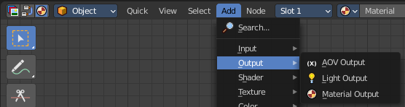

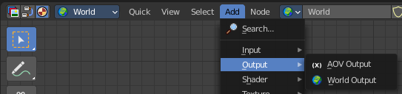

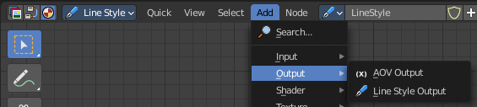

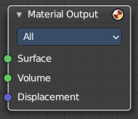
Material Output
The Material Output node is used to output surface material information to a surface object. It is what goes to the render engine then.

Inputs

Surface
Shading for the surface of the object.

Volume
Shading for the volume inside the object.
The types of volume shaders are:
Emission shader.
Volume Absorption shader.
Volume Scatter shader.

Displacement
Used to create bump mapping or actual subdivided displacement.

Properties

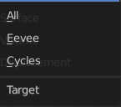
Target
Choose which renderer the output should go to.

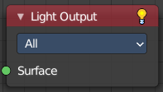
Light Output
Cycles Only
Outputs light information to a light object.

Inputs

Surface
The shading for the surface of the light object.

Properties

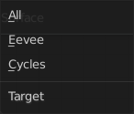
Target
What render engine to use. By default shaders are shared between Cycles and Eevee. By using multiple output nodes specialized shader setups can be created for each.

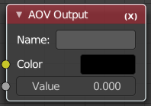
AOV Output
Shader AOVs (Arbitrary Output Variables) provide custom render passes for arbitrary shader node components. As an artist this can be a good way to debug or tweak very fine details of a scene in post processing. To use shader AOVs create the pass in the Shader AOV panel then reference that pass with the AOV Output shading node. Shader AOVs can be added or removed in the Shader AOV panel.
Tip! The AOV Output node can be used in Material and World shader nodes.

Inputs

Color
Output a color variable; as the name suggest can be used for a color but also a normal value.

Value
Output a single numerical value.

Properties

Name
The name of the render pass to assign the input value to. This property is the same Name that is specified in the Shader AOV panel.

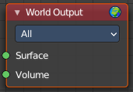
World Output
Shader type World. The World Output node is used to output light a color information to the scene’s World.

Inputs

Surface
The appearance of the environment, usually preceded by a Background shader.

Volume
Used to add volumetric effects to the world. See the shaders Volume Absorption and Volume Scatter for more information.

Note
It is not possible to have an HDR and volumetric due to the fact that HDR’s are assumed to be an infinite distance from the camera.

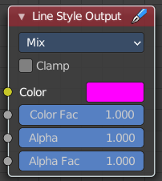
Line Style Output
Shader Type Line Style

Inputs

Color
The input color.

Color factor
The factor for the color.

Alpha
Alpha channel information.

Alpha Factor
The factor for the alpha channel.

Properties

Blending Mode
Choose the Blending mode.

Clamp
Clamp the result to the range between 0 and 1.

